Database Schema for Classicmodels

The MySQL sample database schema consists of the following tables:

* customers: stores customer’s data.
* products: stores a list of scale model cars.
* productlines: stores a list of product lines.
* orders: stores sales orders placed by customers.
* orderdetails: stores sales order line items for every sales order.
* payments: stores payments made by customers based on their accounts.
* employees: stores employee information and the organization structure such as who reports to whom.
* offices: stores sales office data.

The following picture illustrates the ER diagram of the sample database:

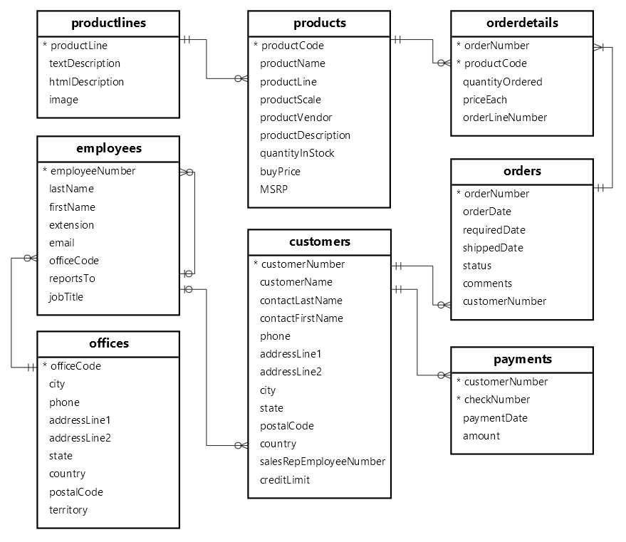

|  |  |  |  |  |
| --- | --- | --- | --- | --- |
| Table Name | Columns | Data Type & Size | Null | Keys |
| customers | customerNumber | INT(11) | NO | PRI |
|  | customerName | VARCHAR(50) | NO |  |
|  | contactLastName | VARCHAR(50) | NO |  |
|  | contactFirstName | VARCHAR(50) | NO |  |
|  | phone | VARCHAR(50) | NO |  |
|  | addressLine1 | VARCHAR(50) | NO |  |
|  | addressLine2 | VARCHAR(50) | YES |  |
|  | city | VARCHAR(50) | NO |  |
|  | state | VARCHAR(50) | YES |  |
|  | postalCode | VARCHAR(50) | YES |  |
|  | country | VARCHAR(50) | NO |  |
|  | salesRepEmployeeNumber | INT(11) | YES | MUL |
|  | creditLimit | DECIMAL(10,2) | YES |  |
|  |  |  |  |  |
| products | productCode | VARCHAR(15) | NO | PRI |
|  | productName | VARCHAR(70) | NO |  |
|  | productLine | VARCHAR(50) | NO | MUL |
|  | productScale | VARCHAR(10) | NO |  |
|  | productVendor | VARCHAR(50) | NO |  |
|  | productDescription | TEXT | NO |  |
|  | quantityInStock | SMALLINT(6) | NO |  |
|  | buyPrice | DECIMAL(10,2) | NO |  |
|  | MSRP | DECIMAL(10,2) | NO |  |
|  |  |  |  |  |
| productlines | productLine | VARCHAR(50) | NO | PRI |
|  | textProduction | VARCHAR(4000) | YES |  |
|  | htmlDescription | MEDIUMTEXT | YES |  |
|  | image | MEDIUMBLOB | YES |  |
|  |  |  |  |  |
| orders | orderNumber | INT(11) | NO | PRI |
|  | orderDate | DATE | NO |  |
|  | requiredDate | DATE | NO |  |
|  | shippedDate | DATE | YES |  |
|  | status | VARCHAR(15) | NO |  |
|  | comments | TEXT | YES |  |
|  | customerNumber | INT(11) | NO | MUL |
|  |  |  |  |  |
| orderdetails | orderNumber | INT(11) | NO | PRI |
|  | productCode | VARCHAR(15) | NO | PRI |
|  | quantityOrdered | INT(11) | NO |  |
|  | priceEach | DECIMAL(10,2) | NO |  |
|  | orderLineNumber | SMALLINT(6) | NO |  |
|  |  |  |  |  |
|  |  |  |  |  |
| payments | customerNumber | INT(11) | NO | PRI |
|  | checkNumber | VARCHAR(50) | NO | PRI |
|  | paymentDate | DATE | NO |  |
|  | amount | DECIMAL(10,2) | NO |  |
|  |  |  |  |  |
| employees | employeeNumber | INT(11) | NO | PRI |
|  | lastName | VARCHAR(50) | NO |  |
|  | firstName | VARCHAR(50) | NO |  |
|  | extension | VARCHAR(10) | NO |  |
|  | email | VARCHAR(100) | NO |  |
|  | officeCode | VARCHAR(10) | NO | MUL |
|  | reportsTo | INT(11) | YES | MUL |
|  | jobTitle | VARCHAR(50) | NO |  |
|  |  |  |  |  |
| offices | officeCode | VARCHAR(10) | NO | PRI |
|  | city | VARCHAR(50) | NO |  |
|  | phone | VARCHAR(50) | NO |  |
|  | addressLine1 | VARCHAR(50) | YES |  |
|  | addressLine2 | VARCHAR(50) | YES |  |
|  | state | VARCHAR(50) | NO |  |
|  | country | VARCHAR(50) | NO |  |
|  | postalCode | VARCHAR(15) | NO |  |
|  | territory | VARCHAR(10) | NO |  |